**TITLE : TRAFFIC BREAKDOWN MANAGEMENT SYSTEM**

**Description** :

In real life, there are number of vehicles are going on road.

We are daily using the vehicles like bikes, cars etc. They are suffering from Breakdowns on roads.

In multinational companies, there are thousands of employees are working but they are assigning a particular task to the employees based on their job.

The works will done very easily when we schedule the jobs properly.

**Problem Statement** :

There are many problems for scheduling the jobs like:

* Vehicles breakdown problems
* job shop scheduling
* Petrol problem
* Accidents occurring problems
* employees scheduling problem

**Example 1:** If we see in Vehicles, there is a problem by Breakdown the vehicles. The scheduling of employees is to solve the breakdown vehicles. It is complex because it involves **assigning the right people to the right job at the right time**. It is conditioned by several legal, work and other organizational rule.

**Example 2:** In the Vehicles Petrol problem, **the goal is to find where the vehicles are facing problem with petrol and identify and supply the petrol with employment by that vehicles visiting a set of locations** by the set of latest technology.

 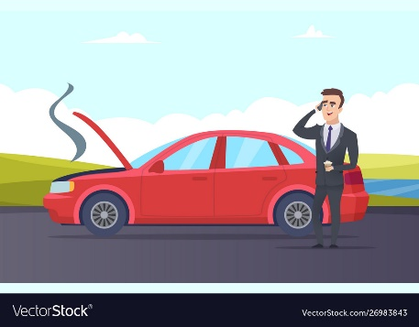 

**Breakdown Problem** **Communicating the employee Helping the employee With our project**

Our goal of this project is to schedule the employment to help the breakdown vehicles by using this project.­­­